34.1: If up is the 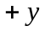-direction and right is the 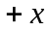-direction, then the object is at 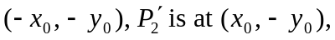and mirror 1 flips the -values, so the image is at 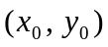which is 